Link 10 Wiring
The Link 10 is mounted in the attic control panel and connected to the shunt/sensor located near the batteries in the rear compartment. The manufacturer’s wiring diagram is below.
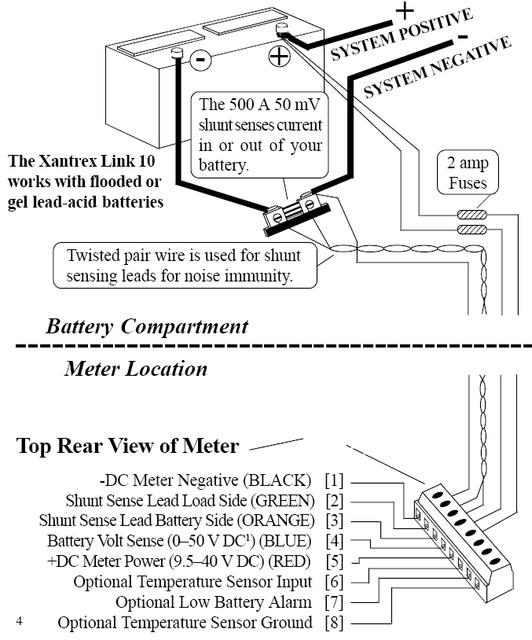

Xantrex support confirmed 18 AWG wire is adequate for the 30’ run required. The twisted pair should be twisted at two twists per inch. The two connections shown from the battery’s positive terminal to pins four and five on the meter can be combined and protected with a single, 2 amp, fuse.
Color code for this installation is:
Meter | Color | Equipment
1 | Black | Shunt, load side, main terminal
2 | Green | Shunt, sensor, battery negative
3 | White | Shunt, sensor, load negative
4 - 5 | Red | Battery + ( 2 amp fused )

