Paws At Your Door

Black Water Holding Tank - order details
The tank will be Ardemco RV/Bus tank Model B319HD, with a wall thickness of ¼”. The nominal tank dimensions are 35” x 19.5” x 4.75”. These are taken to be the external dimensions.
The photo below shows the tank area marked off with masking tape and fittings indicating the inlet and outlet locations. The bottom, or outlet, fitting will be used for a standard 3” RV-type waste valve. The inlet fitting will be used for a toilet flange using a 3” threaded connection.
All threaded fittings will be “recessed.”
Dimensional drawings below show details. The inlet, on the top of the tank, will be centered 11” from the right-hand side of the tank, as shown. The inlet will be centered 12” from the rear of the tank, as shown
The outlet fitting, on the bottom, will be centered 19.75” from the right side of the tank, as shown. The outlet fitting will be centered 3.75” from the rear of the tank as shown.
The vent shall be a 1” fitting. This will be on the left end of the tank, as shown. The vent fitting will be approximately 6” from the rear of the tank, as shown. This dimension is not critical. The opening should be as close to the top of the tank as the manufacturing process will allow.

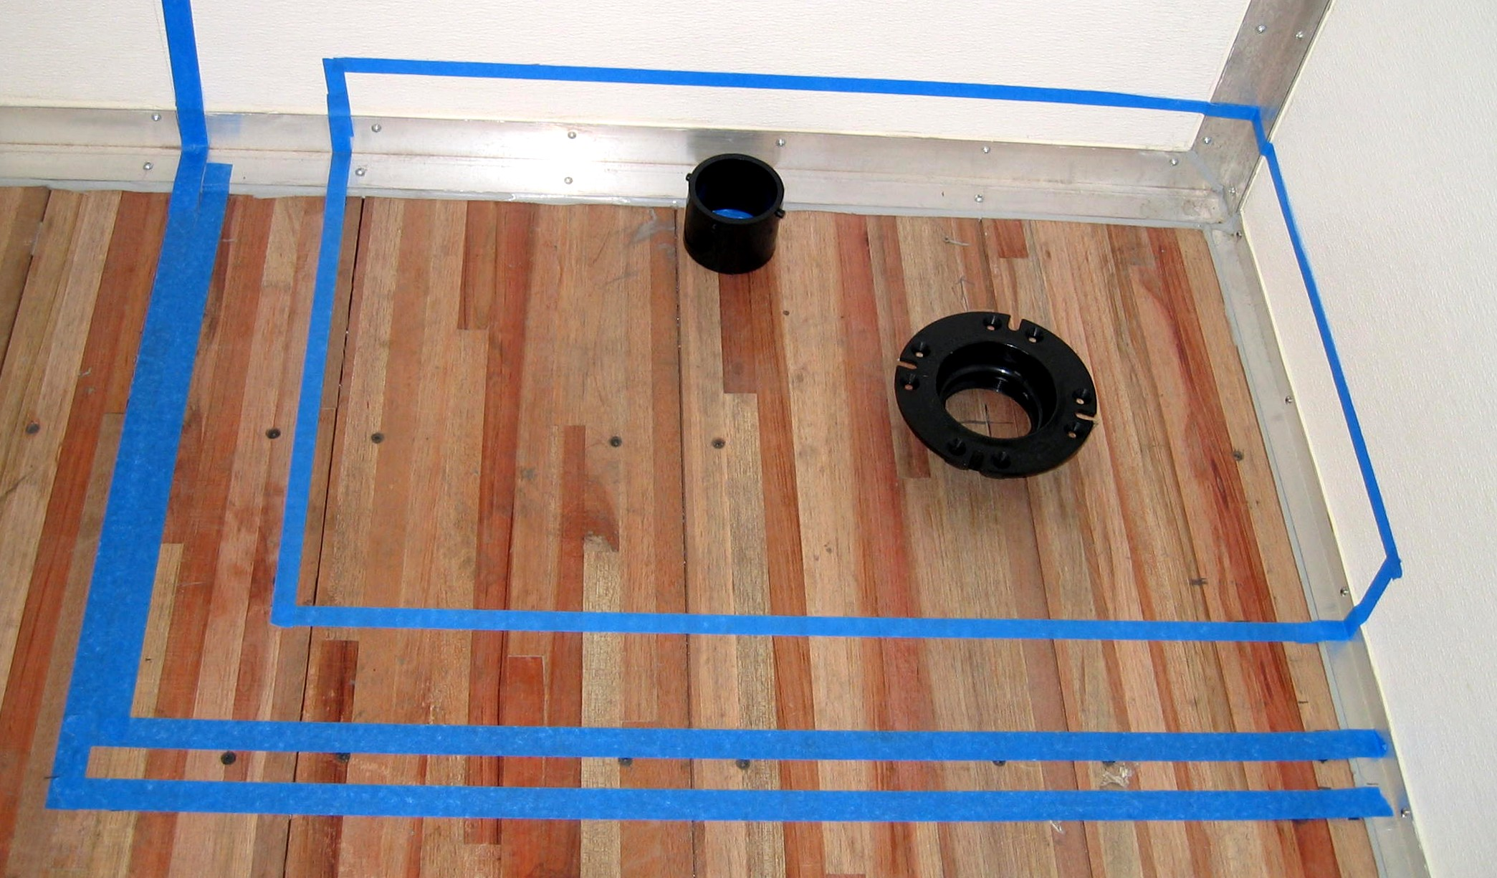

Tank Dimensions

