Paws At Your Door

Gray Water Holding Tank - order details
The tank will be Ardemco RV/Bus tank Model B507, with a wall thickness of ¼”. The nominal tank dimensions are 33.25” x 24.5” x 15”. These are taken to be the external dimensions.
The photo below shows the tank area marked off with masking tape and metal rings indicating the inlet and outlet fitting locations. The bottom, or outlet, fitting will be used for a standard 3” RV-type waste valve. The inlet fitting will be used for a standard 1 ½” PVC drain fitting.
Dimensional drawings below show details. The outlet, on the bottom of the tank, will be centered 18” from the right-hand side of the space, as shown. The outlet will be centered 151/2” from the rear of the tank, as shown. For reference, the inlet fitting is on the side here referred to as “rear.”
The inlet fitting will be centered 21” from the right-hand side of the space, as shown. The inlet fitting should be as close to the top of the tank as manufacturing processes allow.
The vent shall be a 1” fitting. This will be located on the top of the tank, between 19” and 21” from the right-hand side of the tank. The vent will be located as close to 21” from the right-hand edge of the tank as possible without interfering with the inlet fitting on the rear of the tank.

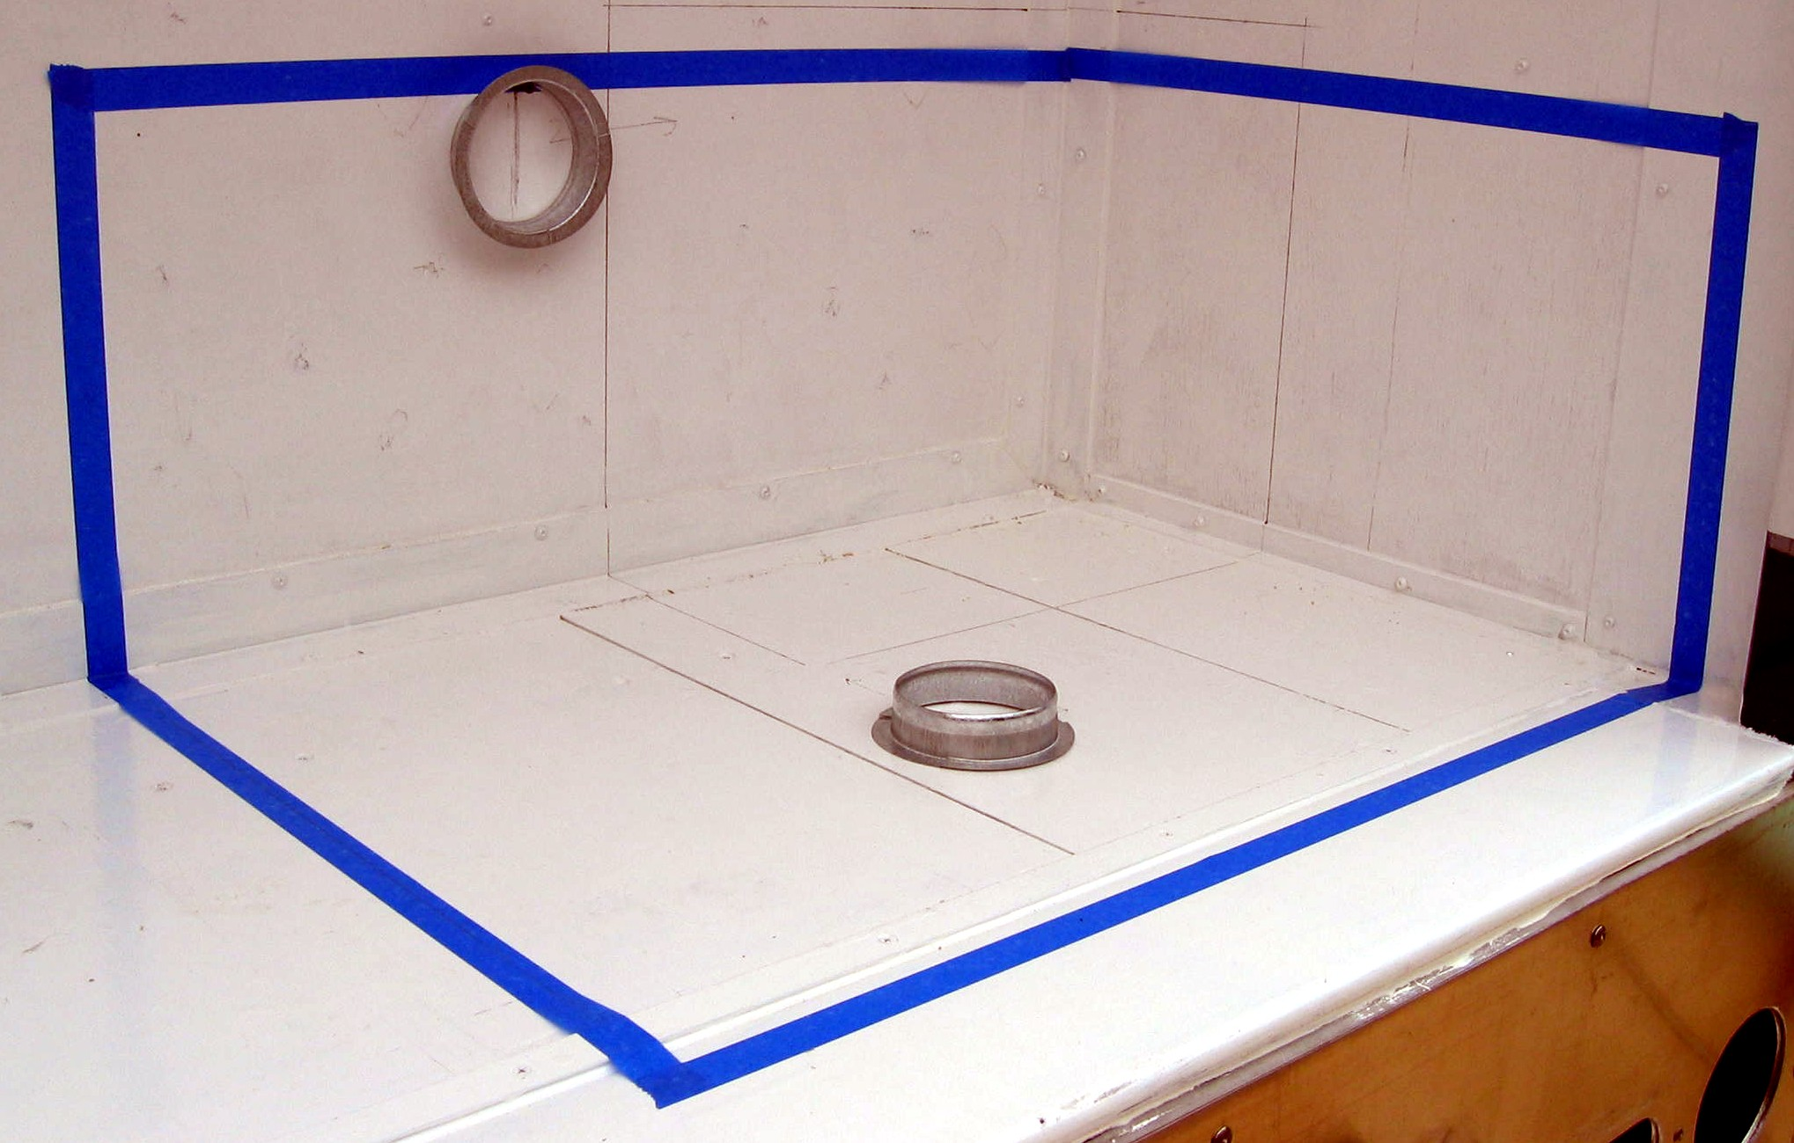

Tank Dimensions

